Ballard Arinc-429 Add-On
https://github.com/NIVeriStandAdd-Ons/Ballard-Arinc-429-Custom-Device

Known Limitations
- This add-on supports one Core only (8 or 16 Arinc-429 Channels).
Compilation instructions
- Before any compilation, some functions from the driver needs some changes. For the following VIs, all DLL calls must be changed from “UI Thread” to “Any Thread”. These functions are called inside Timed-Loop. VIs:
  - Set Scheduled Message Data.vi
  - Enable Scheduled Message.vi
  - Disable Scheduled Message.vi
  - Get Sequential Monitor Status.vi
  - Read.vi
  - Get Next 429 Record In Reader.vi
  - Get Activity Fields Cluster.vi
  - Get Field Label.vi
- To prevent some naming collisions during compilation, some VIs must be renamed in the BTI429LV.lvlib. Below is the list, in the capture. For all VIs within red circles, change names to match the capture.
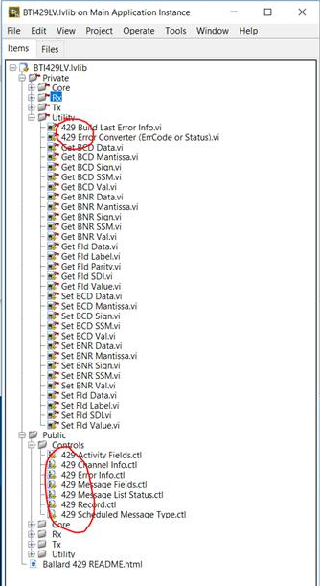
- Configuration part. Under “My computer” target, execute “Configuration Release” Build Specifications.
- Engine part. Under “RT PXI Target” target, execute “Engine Release” Build Specifications.
- Once 2 previous steps executed, respective Build Specifications completes process by copying resulting files to local NI-VeriStand “Custom Devices” folder in a sub-folder called “Ballard – Arinc-429”.

Upgrade instructions
Not applicable

To install this add-on for USE:
With NI VeriStand closed:
- To copy Ballard Arinc-429 Custom-Device on other machines without LabVIEW tools, the sub-folder called “Ballard – Arinc-429” often located at “C:\Users\Public\Documents\National Instruments\NI VeriStand 2017\Custom Devices” on Development machine (once Compilation steps completed) should be copied to same folder on other machines (Deployment machines).

XML Configuration File
- It’s important to note that not all XML elements from XSD schema are supported. Integration to NI-VeriStand imposes some restrictions.
- XML File can be edited using shipping tool from Ballard called: “BTIXMLEdit”. It’s a graphical tool which allows to edit XML tool and also to Validate content of XML tool to ensure that XML is compliant to XML XSD Schema.
- With the source code, there are XML files available. These files have “NOTES” at the top giving explanation of the different elements. It’s important to note that a XML file validated with “BTIXMLEdit” may not give expected results once in NI-VeriStand if recommendations/approaches given in XML files examples are not followed.
- For Channels speed (Tx and Rx), only attribute “speedKHz” is supported. Accepted values are: 12.5 or 100. The XML parser converts that to either “Low” (12.5 kHz) or “High” (100 kHz). Default value is 100 (converted to “High”).
- For Channels configured in Rx:
  - The general approach is to list all Labels present on the Channel and use “monitor” XML element to define whether the Label is made available to NI-VeriStand (true) or filtered (false).
  - “SDI” XML element can be used to create a SDI filter.
- For Channels configured in Tx:
  - For each Label and “messageBuffer”, only first element “rawData” is considered whatever number of elements are listed in XML file.
  - For “rawData”, it’s important to set that element as it’s used for default start value for considered Label. If not used, there would be a difference between NI-VeriStand Channel default value and actual value sent on physical Channel.
  - For “txChannel”, for attribute “scheduleBuildUnit”, values accepted are either: “Microsecond” or “Millisecond”. In addition to minRate and maxRate, it allows to define transmission period.
- For “message” element, “SDI” attribute can be used to limit SDI value sent.

